UNITED STATES
SECURITIES AND EXCHANGE COMMISSION
Washington, D.C. 20549

FORM 8-K

Current Report
Pursuant to Section 13 or 15(d)
of the Securities Exchange Act of 1934
Date of Report (Date of earliest event reported) July 30, 2024


LANDSTAR SYSTEM, INC.
(Exact name of registrant as specified in its charter)

Delaware |  | 021238 |  | 06-1313069
(State or other jurisdiction  of incorporation) |  | (Commission  File Number) |  | (I.R.S. Employer  Identification No.)

13410 Sutton Park Drive South, Jacksonville, Florida |  | 32224
(Address of principal executive offices) |  | (Zip Code)
(904) 398-9400
(Registrant’s telephone number, including area code)
N/A
(Former name or former address, if changed since last report)

Check the appropriate box below if the Form 8-K filing is intended to simultaneously satisfy the filing obligation of the registrant under any of the following provisions:

☐ | Written communications pursuant to Rule 425 under the Securities Act (17 CFR 230.425)

☐ | Soliciting material pursuant to Rule 14a-12 under the Exchange Act (17 CFR 240.14a-12)

☐ | Pre-commencement communications pursuant to Rule 14d-2(b) under the Exchange Act (17 CFR 240.14d-2(b))

☐ | Pre-commencement communications pursuant to Rule 13e-4(c) under the Exchange Act (17 CFR 240.13e-4(c))
Securities registered pursuant to Section 12(b) of the Act:

Title of each class |  | Trading  Symbol(s) |  | Name of each exchange  on which registered
Common Stock |  | LSTR |  | NASDAQ
Indicate by check mark whether the registrant is an emerging growth company as defined in Rule 405 of the Securities Act of 1933 (§230.405 of this chapter) or Rule 12b-2 of the Securities Exchange Act of 1934 (§240.12b-2 of this chapter).
Emerging growth company ☐
If an emerging growth company, indicate by check mark if the registrant has elected not to use the extended transition period for complying with any new or revised financial accounting standards provided pursuant to Section 13(a) of the Exchange Act. ☐

Item 2.02 | Results of Operations and Financial Condition
On July 30, 2024, Landstar System, Inc. (“Landstar” or the “Company”) issued a press release announcing results for the second quarter of fiscal 2024. A copy of the press release is attached hereto as Exhibit 99.1.
The information contained in Item 7.01 concerning the presentation to Landstar investors is hereby incorporated into this Item 2.02 by reference.
The information furnished under Item 2.02 of this Current Report on Form 8-K, including Exhibit 99.1 hereto, shall not be deemed “filed” for purposes of Section 18 of the Securities Exchange Act of 1934, nor shall it be deemed incorporated by reference in any filing under the Securities Act of 1933.

Item 7.01 | Regulation FD Disclosure
A slide presentation, dated July 30, 2024, is attached hereto as Exhibit 99.2 and is incorporated herein by reference. The slide presentation provides information that may be referred to by the Company on its conference call with investors scheduled to occur on July 30, 2024 in connection with the Company’s release of results for the second quarter of fiscal 2024.
The information furnished under Item 7.01 of this Current Report on Form 8-K, including Exhibit 99.2 hereto, shall not be deemed “filed” for purposes of Section 18 of the Securities Exchange Act of 1934, nor shall it be deemed incorporated by reference in any filing under the Securities Act of 1933.

Item 9.01 | Financial Statements and Exhibits

Exhibits
99.1 |  | Press Release, dated July 30, 2024, of Landstar System, Inc.
99.2 |  | Slide Presentation, dated July 30, 2024, of Landstar System, Inc.
104 |  | Inline XBRL for the cover page of this Current Report on Form 8-K

SIGNATURES
Pursuant to the requirements of the Securities Exchange Act of 1934, the Registrant has duly caused this report to be signed on its behalf by the undersigned hereunto duly authorized.

 |  |  |  | LANDSTAR SYSTEM, INC.
Date: July 30, 2024 |  |  |  | By: |  | /s/ James P. Todd
 |  |  |  | Name: |  | James P. Todd
 |  |  |  | Title: |  | Vice President, Chief Financial Officer  and Assistant Secretary
Exhibit 99.1



For Immediate Release |  | July 30, 2024
LANDSTAR SYSTEM REPORTS SECOND QUARTER
REVENUE OF $1.225B AND EARNINGS PER SHARE OF $1.48
AND ANNOUNCES 9% INCREASE TO QUARTERLY DIVIDEND
Jacksonville, FLLandstar System, Inc. (NASDAQ: LSTR) (Landstar or the Company) today reported basic and diluted earnings per share (EPS) of $1.48 in the 2024 second quarter on revenue of $1.225 billion. The Landstar network of independent business owners performed admirably in a challenging freight transportation environment, said Landstar President and Chief Executive Officer Frank Lonegro. During the second quarter, we were encouraged to see our first sequential quarter-to-quarter revenue increase since the 2022 second quarter. Revenue in the 2024 second quarter grew 5% sequentially following seven quarters of sequential revenue declines. As we look to build on that momentum, we continue to invest in leading-edge technology and new trailing equipment. We are particularly proud of the efforts of the thousands of BCOs, agents and employees in our network, who work each day to improve our safety performance and deliver great service to our customers.
Landstar continues to return meaningful amounts of capital to stockholders through the Companys stock purchase program and dividends. During the 2024 second quarter, Landstar purchased approximately 316,000 shares of its common stock at an aggregate cost of $57.0 million. The Company is currently authorized to purchase up to an additional 2,684,000 shares of the Companys common stock under its longstanding share purchase program. Landstar also announced today that its Board of Directors declared a quarterly dividend of $0.36 per share payable on September 10, 2024, to stockholders of record as of the close of business on August 20, 2024. This quarterly dividend includes a $0.03 per share increase, or 9%, over the amount of the Companys regular quarterly dividend declared following each of the prior four quarters.

LANDSTAR SYSTEM/2

 |  | 2Q 2024 |  |  |  | 2Q 2023
Revenue |  | $ | 1,225,005 |  |  | $ | 1,373,857
Gross profit |  | $ | 119,996 |  |  | $ | 139,706
Variable contribution |  | $ | 175,131 |  |  | $ | 198,182
Operating income |  | $ | 68,059 |  |  | $ | 87,950
Basic and diluted earnings per share |  | $ | 1.48 |  |  | $ | 1.85

(1) | Dollars above in thousands, except per share amounts
(2) | Please refer to the Consolidated Statements of Income and Reconciliation of Gross Profit to Variable Contribution included below
Total revenue was $1,225 million in the 2024 second quarter, compared to $1,374 million in the 2023 second quarter. Truck transportation revenue hauled by independent business capacity owners (BCOs) and truck brokerage carriers in the 2024 second quarter was $1,106 million, or 90% of revenue, compared to $1,247 million, or 91% of revenue, in the 2023 second quarter. Truckload transportation revenue hauled via van equipment in the 2024 second quarter was $619 million, compared to $703 million in the 2023 second quarter. Truckload transportation revenue hauled via unsided/platform equipment in the 2024 second quarter was $381 million, compared to $395 million in the 2023 second quarter. Revenue from other truck transportation, which is largely related to power-only services, in the 2024 second quarter was $78 million, compared to $118 million in the 2023 second quarter. Revenue hauled by rail, air and ocean cargo carriers was $94 million, or 8% of revenue, in the 2024 second quarter, compared to $101 million, or 7% of revenue, in the 2023 second quarter.
The number of loads hauled via truck declined 8.9% in the 2024 second quarter as compared to the 2023 second quarter, at the low end of the Companys guidance included in its 2024 first quarter earnings release slide presentation, dated April 25, 2024. Truck revenue per load declined 2.6% in the 2024 second quarter as compared to the 2023 second quarter, slightly below the mid-point of the Companys previously provided guidance.
Gross profit in the 2024 second quarter was $120 million and variable contribution (defined as revenue less the cost of purchased transportation and commissions to agents) in the 2024 second quarter was $175 million. Gross profit in the 2023 second quarter was $140 million and variable contribution in the 2023 second quarter was $198 million. Reconciliations of gross profit to variable contribution and gross profit margin to variable contribution margin for the 2024 and 2023 second quarters and year-to-date periods are provided in the Companys accompanying financial disclosures.

LANDSTAR SYSTEM/3

The Companys balance sheet continues to be very strong, with cash and short-term investments of approximately $504 million as of June 29, 2024. Trailing twelve-month return on average shareholders equity was 22%, and return on invested capital, representing net income divided by the sum of average equity plus average debt, was 20%.
Landstar will provide a live webcast of its quarterly earnings conference call this evening at 5:00 p.m. ET. To access the webcast, visit www.investor.landstar.com; click on Webcasts, then click on Landstars Second Quarter 2024 Earnings Release Conference Call. A slide presentation to accompany the webcast presentation is also available on Landstars investor relations website at https://investor.landstar.com/.
Contact:
Jim Todd
Chief Financial Officer
904-398-9400
About Landstar:
Landstar System, Inc., is a technology-enabled, asset-light provider of integrated transportation management solutions delivering safe, specialized transportation services to a broad range of customers utilizing a network of agents, third-party capacity providers and employees. Landstar transportation services companies are certified to ISO 9001:2015 quality management system standards and RC14001:2015 environmental, health, safety and security management system standards. Landstar System, Inc. is headquartered in Jacksonville, Florida. Its common stock trades on The NASDAQ Stock Market® under the symbol LSTR.

LANDSTAR SYSTEM/4

Non-GAAP Financial Measures:
In this earnings release and accompanying financial disclosures, the Company provides the following information that may be deemed a non-GAAP financial measure: variable contribution and variable contribution margin. The Company believes variable contribution and variable contribution margin are useful measures of the variable costs that we incur at a shipment-by-shipment level attributable to our transportation network of third-party capacity providers and independent agents in order to provide services to our customers. The Company also believes that it is appropriate to present each of the financial measures that may be deemed a non-GAAP financial measure, as referred to above, for the following reasons: (1) disclosure of these matters will allow investors to better understand the underlying trends in the Companys financial condition and results of operations; (2) this information will facilitate comparisons by investors of the Companys results as compared to the results of peer companies; and (3) management considers this financial information in its decision making.
Forward Looking Statements Disclaimer:
The following is a safe harbor statement under the Private Securities Litigation Reform Act of 1995. Statements contained in this press release that are not based on historical facts are forward-looking statements. This press release contains forward-looking statements, such as statements which relate to Landstars business objectives, plans, strategies and expectations. Terms such as anticipates, believes, estimates, intention, expects, plans, predicts, may, should, could, will, the negative thereof and similar expressions are intended to identify forward-looking statements. Such statements are by nature subject to uncertainties and risks, including but not limited to: an increase in the frequency or severity of accidents or other claims; unfavorable development of existing accident claims; dependence on third party insurance companies; dependence on independent commission sales agents; dependence on third party capacity providers; the impact of the Russian conflict with Ukraine on the operations of certain independent commission sales agents, including the Companys largest such agent by revenue in the 2023 fiscal year; decreased demand for transportation services; U.S. trade relationships; substantial industry competition; disruptions or failures in the Companys computer systems; cyber and other information security incidents; dependence on key vendors; potential changes in taxes; status of independent contractors; regulatory and legislative changes; regulations focused on diesel emissions and other air quality matters; regulations requiring the purchase and use of zero-emission vehicles; intellectual property; and other operational, financial or legal risks or

LANDSTAR SYSTEM/5

uncertainties detailed in Landstars Form 10-K for the 2023 fiscal year, described in Item 1A Risk Factors, and in other SEC filings from time to time. These risks and uncertainties could cause actual results or events to differ materially from historical results or those anticipated. Investors should not place undue reliance on such forward-looking statements, and the Company undertakes no obligation to publicly update or revise any forward-looking statements.

LANDSTAR SYSTEM/6

Landstar System, Inc. and Subsidiary
Consolidated Statements of Income
(Dollars in thousands, except per share amounts)
(Unaudited)

 |  | Twenty-Six Weeks Ended |  |  |  |  |  |  |  | Thirteen Weeks Ended
 |  | June 29, |  |  |  | July 1, |  |  |  | June 29, |  |  |  | July 1,
 |  | 2024 |  |  |  | 2023 |  |  |  | 2024 |  |  |  | 2023
Revenue |  | $ | 2,396,048 |  |  | $ | 2,809,532 |  |  | $ | 1,225,005 |  |  | $ | 1,373,857
Investment income |  |  | 7,066 |  |  |  | 3,852 |  |  |  | 3,654 |  |  |  | 2,484
Costs and expenses:
Purchased transportation |  |  | 1,855,579 |  |  |  | 2,154,491 |  |  |  | 950,058 |  |  |  | 1,053,197
Commissions to agents |  |  | 197,098 |  |  |  | 248,153 |  |  |  | 99,816 |  |  |  | 122,478
Other operating costs, net of gains on asset sales/dispositions |  |  | 28,994 |  |  |  | 25,840 |  |  |  | 14,135 |  |  |  | 13,462
Insurance and claims |  |  | 53,432 |  |  |  | 57,431 |  |  |  | 27,164 |  |  |  | 29,784
Selling, general and administrative |  |  | 111,361 |  |  |  | 108,096 |  |  |  | 54,939 |  |  |  | 54,529
Depreciation and amortization |  |  | 28,630 |  |  |  | 30,139 |  |  |  | 14,488 |  |  |  | 14,941
Total costs and expenses |  |  | 2,275,094 |  |  |  | 2,624,150 |  |  |  | 1,160,600 |  |  |  | 1,288,391
Operating income |  |  | 128,020 |  |  |  | 189,234 |  |  |  | 68,059 |  |  |  | 87,950
Interest and debt (income) expense |  |  | (3,286 | ) |  |  | (1,033 | ) |  |  | (1,675 | ) |  |  | (307 | )
Income before income taxes |  |  | 131,306 |  |  |  | 190,267 |  |  |  | 69,734 |  |  |  | 88,257
Income taxes |  |  | 31,586 |  |  |  | 45,513 |  |  |  | 17,110 |  |  |  | 21,698
Net income |  | $ | 99,720 |  |  | $ | 144,754 |  |  | $ | 52,624 |  |  | $ | 66,559
Basic and diluted earnings per share |  | $ | 2.79 |  |  | $ | 4.03 |  |  | $ | 1.48 |  |  | $ | 1.85
Average basic and diluted shares outstanding |  |  | 35,702,000 |  |  |  | 35,962,000 |  |  |  | 35,654,000 |  |  |  | 35,941,000
Dividends per common share |  | $ | 0.66 |  |  | $ | 0.60 |  |  | $ | 0.33 |  |  | $ | 0.30

LANDSTAR SYSTEM/7

Landstar System, Inc. and Subsidiary
Consolidated Balance Sheets
(Dollars in thousands, except per share amounts)
(Unaudited)

 |  | June 29, |  |  |  | December 30,
 |  | 2024 |  |  |  | 2023
ASSETS
Current assets:
Cash and cash equivalents |  | $ | 438,062 |  |  | $ | 481,043
Short-term investments |  |  | 65,959 |  |  |  | 59,661
Trade accounts receivable, less allowance of $11,697 and $11,738 |  |  | 724,479 |  |  |  | 743,762
Other receivables, including advances to independent contractors, less allowance of $15,974 and $14,010 |  |  | 42,117 |  |  |  | 43,339
Other current assets |  |  | 44,568 |  |  |  | 24,936
Total current assets |  |  | 1,315,185 |  |  |  | 1,352,741
Operating property, less accumulated depreciation and amortization of $449,364 and $436,682 |  |  | 285,995 |  |  |  | 284,300
Goodwill |  |  | 41,607 |  |  |  | 42,275
Other assets |  |  | 112,417 |  |  |  | 122,530
Total assets |  | $ | 1,755,204 |  |  | $ | 1,801,846
LIABILITIES AND SHAREHOLDERS EQUITY
Current liabilities:
Cash overdraft |  | $ | 58,358 |  |  | $ | 61,541
Accounts payable |  |  | 401,535 |  |  |  | 395,980
Current maturities of long-term debt |  |  | 27,980 |  |  |  | 27,876
Insurance claims |  |  | 42,677 |  |  |  | 41,825
Dividends payable |  |  |  |  |  |  | 71,433
Other current liabilities |  |  | 75,168 |  |  |  | 76,569
Total current liabilities |  |  | 605,718 |  |  |  | 675,224
Long-term debt, excluding current maturities |  |  | 45,397 |  |  |  | 43,264
Insurance claims |  |  | 59,862 |  |  |  | 58,922
Deferred income taxes and other non-current liabilities |  |  | 43,415 |  |  |  | 40,513
Shareholders equity:
Common stock, $0.01 par value, authorized 160,000,000 shares, issued 68,553,927 and 68,497,324 |  |  | 686 |  |  |  | 685
Additional paid-in capital |  |  | 256,084 |  |  |  | 254,642
Retained earnings |  |  | 2,859,786 |  |  |  | 2,783,645
Cost of 33,102,276 and 32,780,651 shares of common stock in treasury |  |  | (2,106,266 | ) |  |  | (2,048,184 | )
Accumulated other comprehensive loss |  |  | (9,478 | ) |  |  | (6,865 | )
Total shareholders equity |  |  | 1,000,812 |  |  |  | 983,923
Total liabilities and shareholders equity |  | $ | 1,755,204 |  |  | $ | 1,801,846

LANDSTAR SYSTEM/8

Landstar System, Inc. and Subsidiary
Supplemental Information
(Unaudited)

 |  | Twenty-Six Weeks Ended |  |  |  |  |  |  |  | Thirteen Weeks Ended
 |  | June 29, |  |  |  | July 1, |  |  |  | June 29, |  |  |  | July 1,
 |  | 2024 |  |  |  | 2023 |  |  |  | 2024 |  |  |  | 2023
Revenue generated through (in thousands):
Truck transportation
Truckload:
Van equipment |  | $ | 1,247,244 |  |  | $ | 1,458,124 |  |  | $ | 618,940 |  |  | $ | 703,041
Unsided/platform equipment |  |  | 723,995 |  |  |  | 772,336 |  |  |  | 380,950 |  |  |  | 394,772
Less-than-truckload |  |  | 53,707 |  |  |  | 62,673 |  |  |  | 28,090 |  |  |  | 31,115
Other truck transportation (1) |  |  | 149,675 |  |  |  | 277,520 |  |  |  | 77,709 |  |  |  | 118,017
Total truck transportation |  |  | 2,174,621 |  |  |  | 2,570,653 |  |  |  | 1,105,689 |  |  |  | 1,246,945
Rail intermodal |  |  | 45,002 |  |  |  | 50,889 |  |  |  | 22,307 |  |  |  | 25,232
Ocean and air cargo carriers |  |  | 125,380 |  |  |  | 136,534 |  |  |  | 71,306 |  |  |  | 75,441
Other (2) |  |  | 51,045 |  |  |  | 51,456 |  |  |  | 25,703 |  |  |  | 26,239
 |  | $ | 2,396,048 |  |  | $ | 2,809,532 |  |  | $ | 1,225,005 |  |  | $ | 1,373,857
Revenue on loads hauled via BCO Independent Contractors (3) included in total truck transportation |  | $ | 918,071 |  |  | $ | 1,034,881 |  |  | $ | 465,510 |  |  | $ | 515,355
Number of loads:
Truck transportation
Truckload:
Van equipment |  |  | 599,973 |  |  |  | 655,036 |  |  |  | 300,959 |  |  |  | 323,082
Unsided/platform equipment |  |  | 244,407 |  |  |  | 263,185 |  |  |  | 126,460 |  |  |  | 135,613
Less-than-truckload |  |  | 82,850 |  |  |  | 93,066 |  |  |  | 42,617 |  |  |  | 46,874
Other truck transportation (1) |  |  | 71,440 |  |  |  | 110,373 |  |  |  | 37,914 |  |  |  | 52,311
Total truck transportation |  |  | 998,670 |  |  |  | 1,121,660 |  |  |  | 507,950 |  |  |  | 557,880
Rail intermodal |  |  | 14,380 |  |  |  | 15,390 |  |  |  | 7,230 |  |  |  | 7,630
Ocean and air cargo carriers |  |  | 17,240 |  |  |  | 16,750 |  |  |  | 8,520 |  |  |  | 8,310
 |  |  | 1,030,290 |  |  |  | 1,153,800 |  |  |  | 523,700 |  |  |  | 573,820
Loads hauled via BCO Independent Contractors (3) included in total truck transportation |  |  | 422,300 |  |  |  | 463,910 |  |  |  | 213,560 |  |  |  | 231,360
Revenue per load:
Truck transportation
Truckload:
Van equipment |  | $ | 2,079 |  |  | $ | 2,226 |  |  | $ | 2,057 |  |  | $ | 2,176
Unsided/platform equipment |  |  | 2,962 |  |  |  | 2,935 |  |  |  | 3,012 |  |  |  | 2,911
Less-than-truckload |  |  | 648 |  |  |  | 673 |  |  |  | 659 |  |  |  | 664
Other truck transportation (1) |  |  | 2,095 |  |  |  | 2,514 |  |  |  | 2,050 |  |  |  | 2,256
Total truck transportation |  |  | 2,178 |  |  |  | 2,292 |  |  |  | 2,177 |  |  |  | 2,235
Rail intermodal |  |  | 3,129 |  |  |  | 3,307 |  |  |  | 3,085 |  |  |  | 3,307
Ocean and air cargo carriers |  |  | 7,273 |  |  |  | 8,151 |  |  |  | 8,369 |  |  |  | 9,078
Revenue per load on loads hauled via BCO Independent Contractors (3) |  | $ | 2,174 |  |  | $ | 2,231 |  |  | $ | 2,180 |  |  | $ | 2,228
Revenue by capacity type (as a % of total revenue):
Truck capacity providers:
BCO Independent Contractors (3) |  |  | 38 | % |  |  | 37 | % |  |  | 38 | % |  |  | 38 | %
Truck Brokerage Carriers |  |  | 52 | % |  |  | 55 | % |  |  | 52 | % |  |  | 53 | %
Rail intermodal |  |  | 2 | % |  |  | 2 | % |  |  | 2 | % |  |  | 2 | %
Ocean and air cargo carriers |  |  | 5 | % |  |  | 5 | % |  |  | 6 | % |  |  | 5 | %
Other |  |  | 2 | % |  |  | 2 | % |  |  | 2 | % |  |  | 2 | %
 |  |  |  |  |  |  |  |  |  | June 29, |  |  |  | July 1,
 |  |  |  |  |  |  |  |  |  | 2024 |  |  |  | 2023
Truck Capacity Providers
BCO Independent Contractors (3) |  |  |  |  |  |  |  |  |  |  | 8,385 |  |  |  | 9,748
Truck Brokerage Carriers:
Approved and active (4) |  |  |  |  |  |  |  |  |  |  | 45,382 |  |  |  | 58,303
Other approved |  |  |  |  |  |  |  |  |  |  | 25,450 |  |  |  | 29,503
 |  |  |  |  |  |  |  |  |  |  | 70,832 |  |  |  | 87,806
Total available truck capacity providers |  |  |  |  |  |  |  |  |  |  | 79,217 |  |  |  | 97,554
Trucks provided by BCO Independent Contractors (3) |  |  |  |  |  |  |  |  |  |  | 9,180 |  |  |  | 10,548

(1) | Includes power-only, expedited, straight truck, cargo van, and miscellaneous other truck transportation revenue generated by the transportation logistics segment. Power-only refers to shipments where the Company furnishes a power unit and an operator but not trailing equipment, which is typically provided by the shipper or consignee.

(2) | Includes primarily reinsurance premium revenue generated by the insurance segment and intra-Mexico transportation services revenue generated by Landstar Metro.

(3) | BCO Independent Contractors are independent contractors who provide truck capacity to the Company under exclusive lease arrangements.

(4) | Active refers to Truck Brokerage Carriers who moved at least one load in the 180 days immediately preceding the fiscal quarter end.

LANDSTAR SYSTEM/9

Landstar System, Inc. and Subsidiary
Reconciliation of Gross Profit to Variable Contribution
(Dollars in thousands)
(Unaudited)

 |  | Twenty-Six Weeks Ended |  |  |  |  |  |  |  | Thirteen Weeks Ended
 |  | June 29, 2024 |  |  |  | July 1, 2023 |  |  |  | June 29, 2024 |  |  |  | July 1, 2023
Revenue |  | $ | 2,396,048 |  |  | $ | 2,809,532 |  |  | $ | 1,225,005 |  |  | $ | 1,373,857
Costs of revenue:
Purchased transportation |  |  | 1,855,579 |  |  |  | 2,154,491 |  |  |  | 950,058 |  |  |  | 1,053,197
Commissions to agents |  |  | 197,098 |  |  |  | 248,153 |  |  |  | 99,816 |  |  |  | 122,478
Variable costs of revenue |  |  | 2,052,677 |  |  |  | 2,402,644 |  |  |  | 1,049,874 |  |  |  | 1,175,675
Trailing equipment depreciation |  |  | 13,834 |  |  |  | 16,519 |  |  |  | 6,937 |  |  |  | 8,150
Information technology costs (1) |  |  | 11,986 |  |  |  | 13,493 |  |  |  | 6,182 |  |  |  | 6,742
Insurance-related costs (2) |  |  | 54,659 |  |  |  | 58,382 |  |  |  | 27,881 |  |  |  | 30,122
Other operating costs |  |  | 28,994 |  |  |  | 25,840 |  |  |  | 14,135 |  |  |  | 13,462
Other costs of revenue |  |  | 109,473 |  |  |  | 114,234 |  |  |  | 55,135 |  |  |  | 58,476
Total costs of revenue |  |  | 2,162,150 |  |  |  | 2,516,878 |  |  |  | 1,105,009 |  |  |  | 1,234,151
Gross profit |  | $ | 233,898 |  |  | $ | 292,654 |  |  | $ | 119,996 |  |  | $ | 139,706
Gross profit margin |  |  | 9.8 | % |  |  | 10.4 | % |  |  | 9.8 | % |  |  | 10.2 | %
Plus: other costs of revenue |  |  | 109,473 |  |  |  | 114,234 |  |  |  | 55,135 |  |  |  | 58,476
Variable contribution |  | $ | 343,371 |  |  | $ | 406,888 |  |  | $ | 175,131 |  |  | $ | 198,182
Variable contribution margin |  |  | 14.3 | % |  |  | 14.5 | % |  |  | 14.3 | % |  |  | 14.4 | %

(1) | Includes costs of revenue incurred related to internally developed software including ASC 350-40 amortization, implementation costs, hosting costs and other support costs utilized to support the Companys independent commission sales agents, third party capacity providers, and customers, included as a portion of depreciation and amortization and of selling, general and administrative in the Companys Consolidated Statements of Income.
(2) | Primarily includes (i) insurance premiums paid for commercial auto liability, general liability, cargo and other lines of coverage related to the transportation of freight; (ii) the related cost of claims incurred under those programs; and (iii) brokerage commissions and other fees incurred relating to the administration of insurance programs available to BCO Independent Contractors that are reinsured by the Company, which are included in selling, general and administrative in the Companys Consolidated Statements of Income.
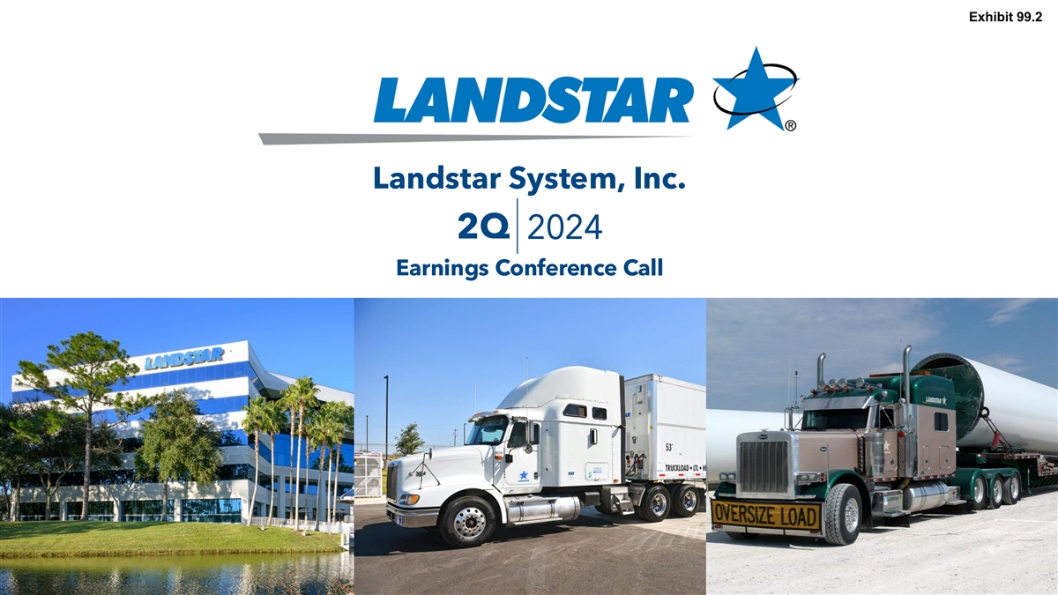
Exhibit 99.2 Landstar System, Inc. 2Q 2024 Earnings Conference Call Date


2Q 2024 Forward-Looking Statements Disclaimer The following is a “safe harbor” statement under the Private Securities Litigation Reform Act of 1995. Statements made in this slide presentation that are not based on historical facts are “forward-looking statements.” This presentation may make certain statements containing forward-looking statements, such as statements which relate to Landstar’s business objectives, plans, strategies and expectations. Such statements are by nature subject to uncertainties and risks, including but not limited to: the operational, financial or legal risks or uncertainties detailed in Landstar’s Form 10-K for the 2023 fiscal year, described in the section Risk Factors, and other SEC filings from time to time. These risks and uncertainties could cause actual results or events to differ materially from historical results or those anticipated. Investors should not place undue reliance on such forward-looking statements, and the Company undertakes no obligation to publicly update or revise any forward-looking statements. 2

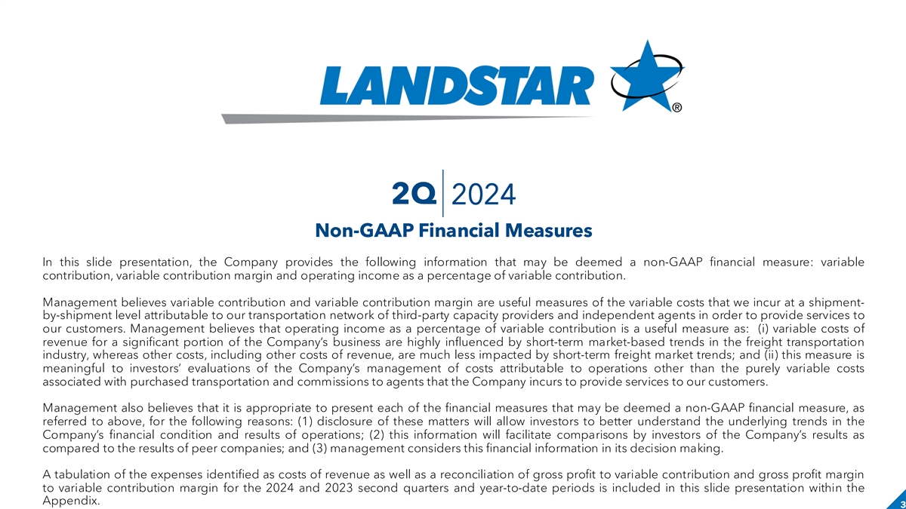
2Q 2024 Non-GAAP Financial Measures In this slide presentation, the Company provides the following information that may be deemed a non-GAAP financial measure: variable contribution, variable contribution margin and operating income as a percentage of variable contribution. Management believes variable contribution and variable contribution margin are useful measures of the variable costs that we incur at a shipment- by-shipment level attributable to our transportation network of third-party capacity providers and independent agents in order to provide services to our customers. Management believes that operating income as a percentage of variable contribution is a useful measure as: (i) variable costs of revenue for a significant portion of the Company’s business are highly influenced by short-term market-based trends in the freight transportation industry, whereas other costs, including other costs of revenue, are much less impacted by short-term freight market trends; and (ii) this measure is meaningful to investors’ evaluations of the Company’s management of costs attributable to operations other than the purely variable costs associated with purchased transportation and commissions to agents that the Company incurs to provide services to our customers. Management also believes that it is appropriate to present each of the financial measures that may be deemed a non-GAAP financial measure, as referred to above, for the following reasons: (1) disclosure of these matters will allow investors to better understand the underlying trends in the Company’s financial condition and results of operations; (2) this information will facilitate comparisons by investors of the Company’s results as compared to the results of peer companies; and (3) management considers this financial information in its decision making. A tabulation of the expenses identified as costs of revenue as well as a reconciliation of gross profit to variable contribution and gross profit margin to variable contribution margin for the 2024 and 2023 second quarters and year-to-date periods is included in this slide presentation within the Appendix. 3

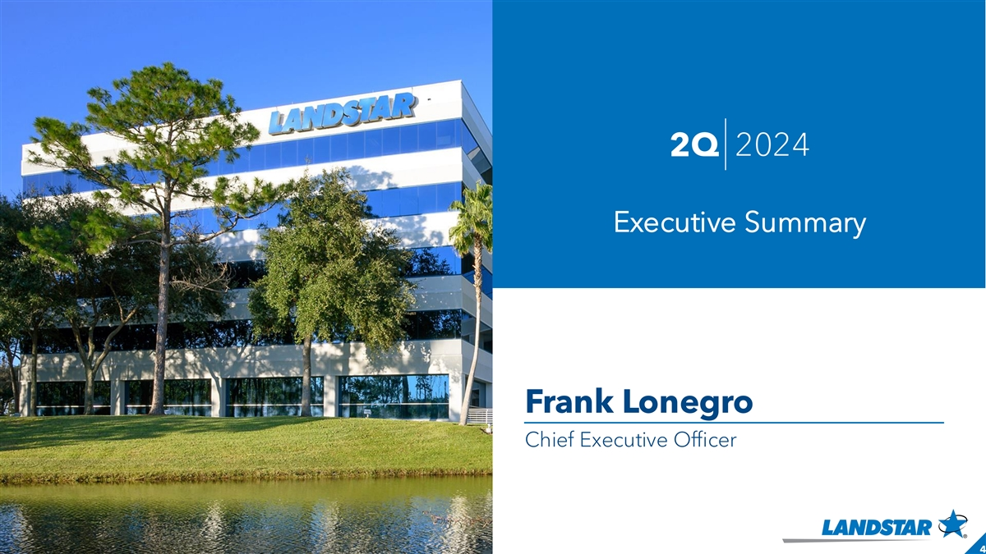
2Q 2024 Executive Summary Frank Lonegro Chief Executive Officer 4

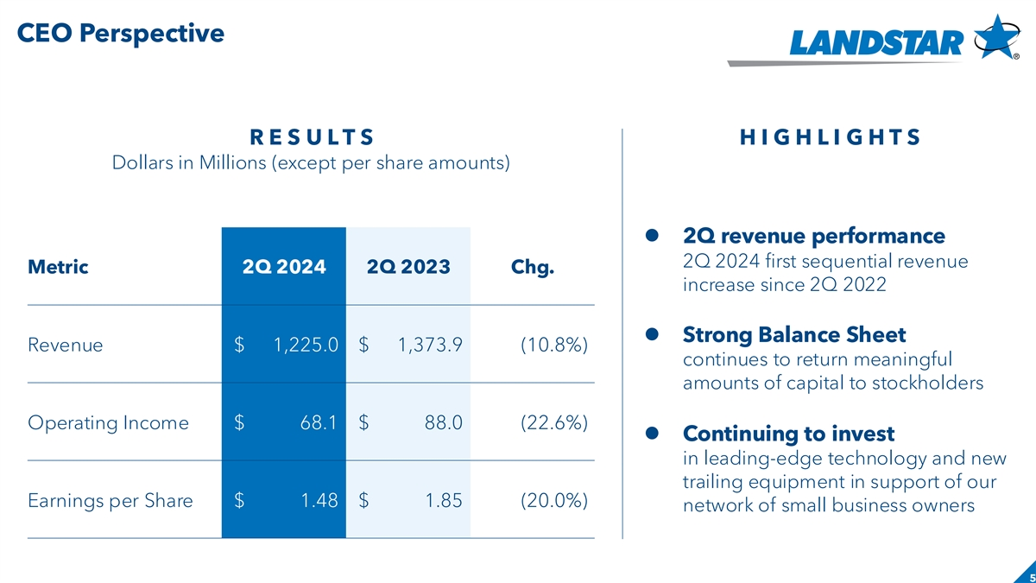
CEO Perspective Slide header R E S U L T S H I G H L I G H T S Dollars in Millions (except per share amounts) ⚫ 2Q revenue performance 2Q 2024 first sequential revenue Metric 2Q 2024 2Q 2023 Chg. increase since 2Q 2022 ⚫ Strong Balance Sheet Revenue $ 1,225.0 $ 1,373.9 (10.8%) continues to return meaningful amounts of capital to stockholders Operating Income $ 68.1 $ 88.0 (22.6%) ⚫ Continuing to invest in leading-edge technology and new trailing equipment in support of our Earnings per Share $ 1.48 $ 1.85 (20.0%) network of small business owners 5

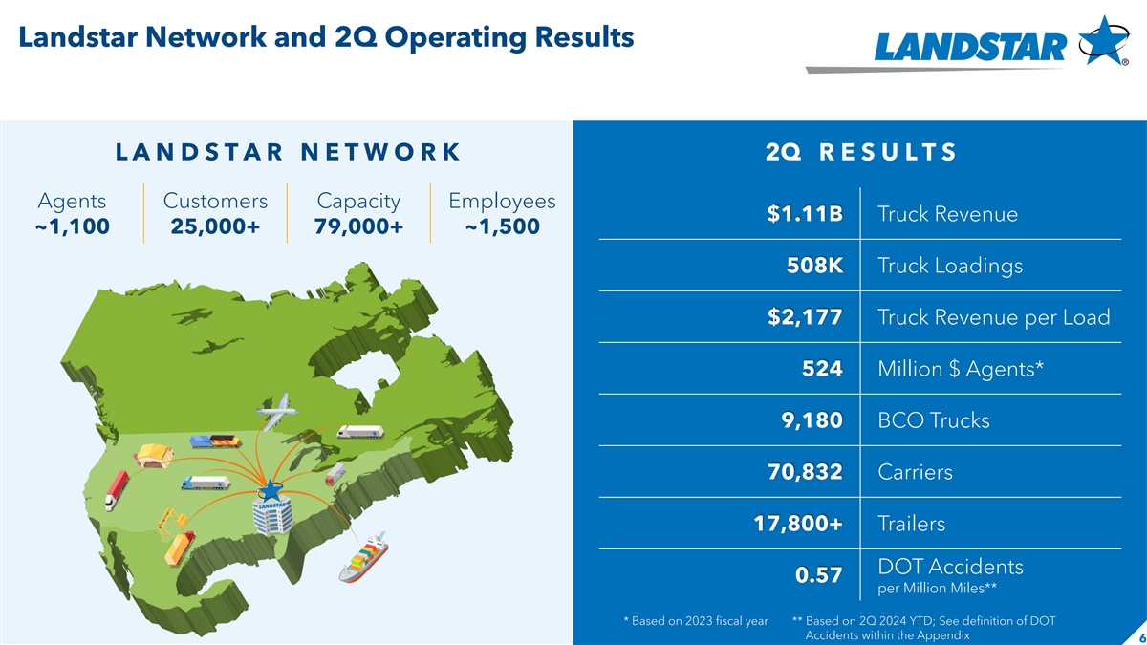
Landstar Network and 2Q Operating Results L A N D S T A R N E T W O R K 2Q R E S U L T S Agents Customers Capacity Employees $1.11B Truck Revenue ~1,100 25,000+ 79,000+ ~1,500 508K Truck Loadings $2,177 Truck Revenue per Load 524 Million $ Agents* 9,180 BCO Trucks 70,832 Carriers 17,800+ Trailers DOT Accidents 0.57 per Million Miles** * Based on 2023 fiscal year ** Based on 2Q 2024 YTD; See definition of DOT Accidents within the Appendix 6

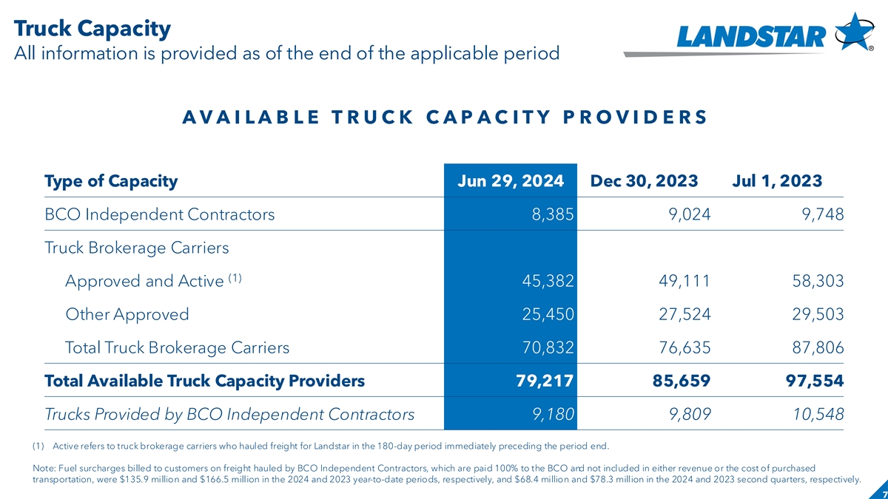
Truck Capacity All information is provided as of the end of the applicable period A V A I L A B L E T R U C K C A P A C I T Y P R O V I D E R S Type of Capacity Jun 29, 2024 Dec 30, 2023 Jul 1, 2023 BCO Independent Contractors 8,385 9,024 9,748 Truck Brokerage Carriers (1) Approved and Active 45,382 49,111 58,303 Other Approved 25,450 27,524 29,503 Total Truck Brokerage Carriers 70,832 76,635 87,806 Total Available Truck Capacity Providers 79,217 85,659 97,554 Trucks Provided by BCO Independent Contractors 9,180 9,809 10,548 (1) Active refers to truck brokerage carriers who hauled freight for Landstar in the 180-day period immediately preceding the period end. Note: Fuel surcharges billed to customers on freight hauled by BCO Independent Contractors, which are paid 100% to the BCO and not included in either revenue or the cost of purchased transportation, were $135.9 million and $166.5 million in the 2024 and 2023 year-to-date periods, respectively, and $68.4 million and $78.3 million in the 2024 and 2023 second quarters, respectively. 7

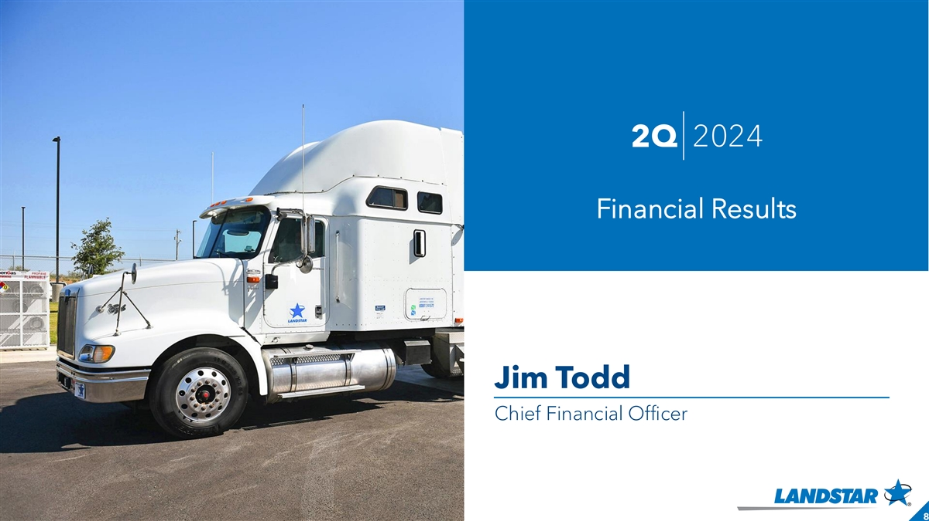
2Q 2024 Financial Results Jim Todd Chief Financial Officer 8

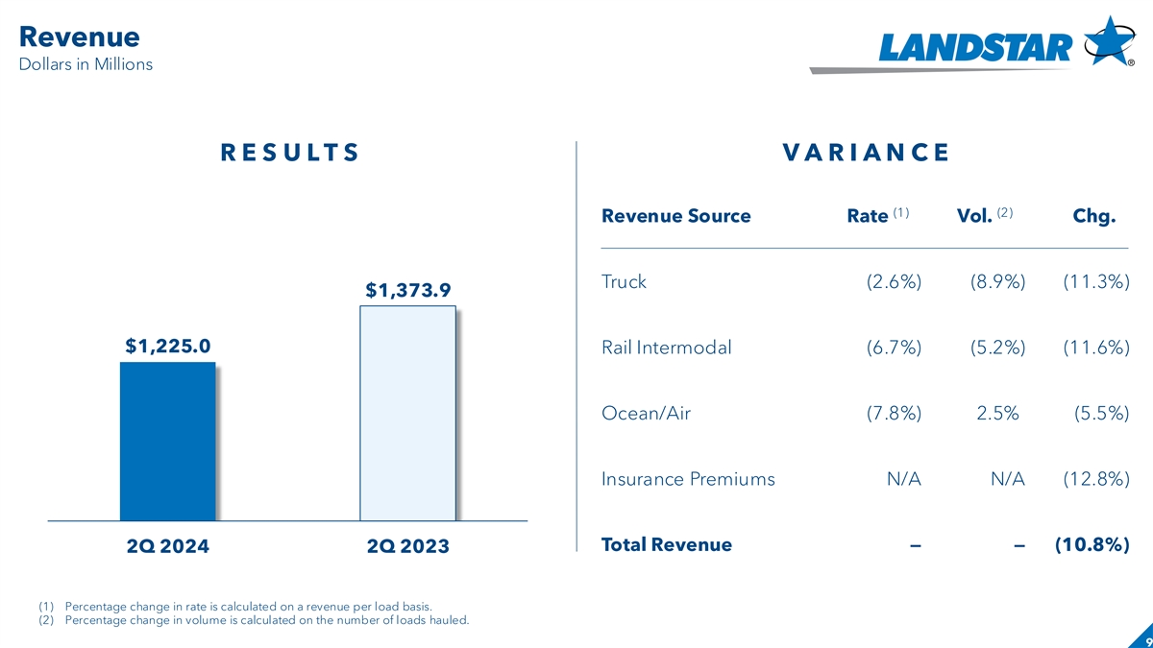
Revenue Slide header Dollars in Millions R E S U L T S V A R I A N C E (1) (2) Revenue Source Rate Vol. Chg. Truck (2.6%) (8.9%) (11.3%) $1,373.9 $1,225.0 Rail Intermodal (6.7%) (5.2%) (11.6%) Ocean/Air (7.8%) 2.5%) (5.5%) Insurance Premiums N/A N/A (12.8%) Total Revenue—— (10.8%) 2Q 2024 2Q 2023 (1) Percentage change in rate is calculated on a revenue per load basis. (2) Percentage change in volume is calculated on the number of loads hauled. 9

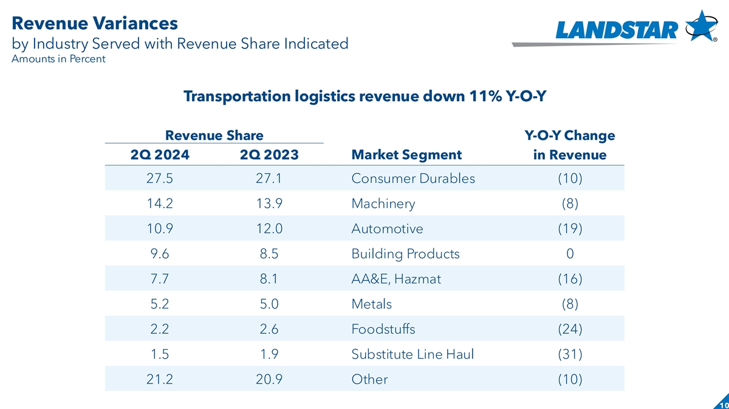
Revenue Variances by Industry Served with Revenue Share Indicated Amounts in Percent Transportation logistics revenue down 11% Y-O-Y Revenue Share Y-O-Y Change Market Segment 2Q 2024 2Q 2023 in Revenue 27.5 27.1 Consumer Durables (10) 14.2 13.9 Machinery (8) 10.9 12.0 Automotive (19) 9.6 8.5 Building Products 0 7.7 8.1 AA&E, Hazmat (16) 5.2 5.0 Metals (8) 2.2 2.6 Foodstuffs (24) 1.5 1.9 Substitute Line Haul (31) 21.2 20.9 Other (10) 10

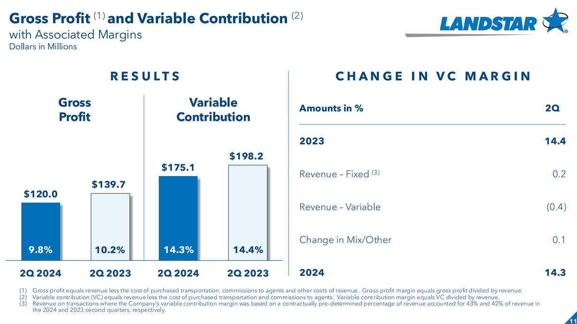
(1) (2) Gross Profit and Variable Contribution with Associated Margins Dollars in Millions R E S U L T S C H A N G E I N V C M A R G I N Gross Variable Amounts in % 2Q Profit Contribution 2023 14.4 $198.2 $175.1 (3) Revenue – Fixed 0.2 $139.7 $120.0 Revenue – Variable (0.4) Change in Mix/Other 0.1 9.8% 10.2% 14.3% 14.4% 2024 14.3 2Q 2024 2Q 2023 2Q 2024 2Q 2023 (1) Gross profit equals revenue less the cost of purchased transportation, commissions to agents and other costs of revenue. Gross profit margin equals gross profit divided by revenue. (2) Variable contribution (VC) equals revenue less the cost of purchased transportation and commissions to agents. Variable cont ribution margin equals VC divided by revenue. (3) Revenue on transactions where the Company’s variable contribution margin was based on a contractually pre-determined percentage of revenue accounted for 43% and 42% of revenue in the 2024 and 2023 second quarters, respectively. 11

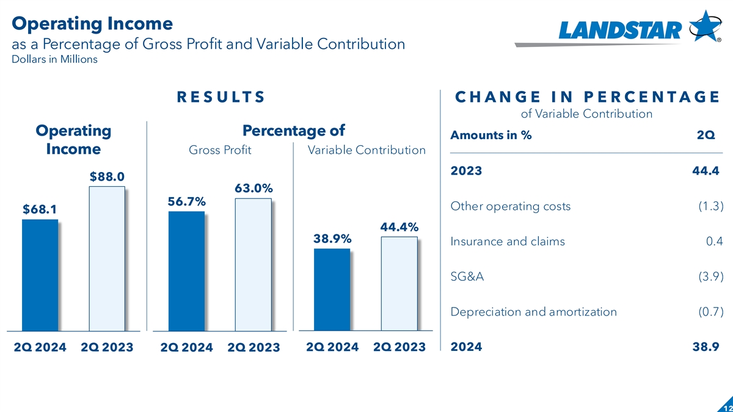
Operating Income Slide header as a Percentage of Gross Profit and Variable Contribution Dollars in Millions R E S U L T S C H A N G E I N P E R C E N T A G E of Variable Contribution Operating Percentage of Amounts in % 2Q Income Gross Profit Variable Contribution 2023 44.4) $88.0 63.0% 56.7% Other operating costs (1.3) $68.1 44.4% 38.9% Insurance and claims 0.4 SG&A (3.9) Depreciation and amortization (0.7) 2Q 2024 2Q 2023 2024 38.9) 2Q 2024 2Q 2023 2Q 2024 2Q 2023 12

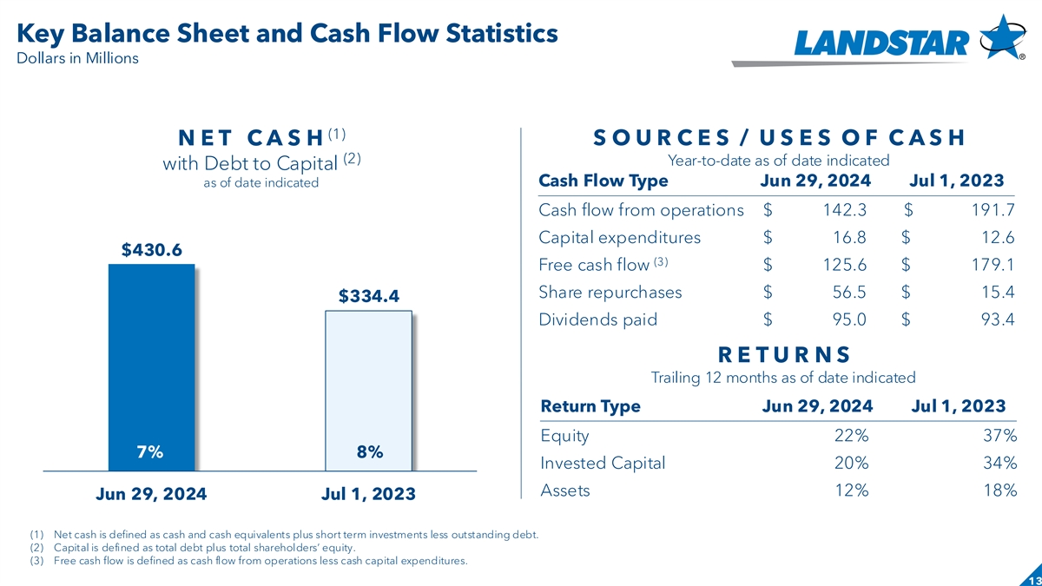
Key Balance Sheet and Cash Flow Statistics Dollars in Millions (1) N E T C A S H S O U R C E S / U S E S O F C A S H (2) Year-to-date as of date indicated with Debt to Capital as of date indicated Cash Flow Type Jun 29, 2024 Jul 1, 2023 Cash flow from operations $ 142.3 $ 191.7 Capital expenditures $ 16.8 $ 12.6 $430.6 (3) Free cash flow $ 125.6 $ 179.1 Share repurchases $ 56.5 $ 15.4 $334.4 Dividends paid $ 95.0 $ 93.4 R E T U R N S Trailing 12 months as of date indicated Return Type Jun 29, 2024 Jul 1, 2023 Equity 22% 37% 7% 8% Invested Capital 20% 34% Assets 12% 18% Jun 29, 2024 Jul 1, 2023 (1) Net cash is defined as cash and cash equivalents plus short term investments less outstanding debt. (2) Capital is defined as total debt plus total shareholders’ equity. (3) Free cash flow is defined as cash flow from operations less cash capital expenditures. 13

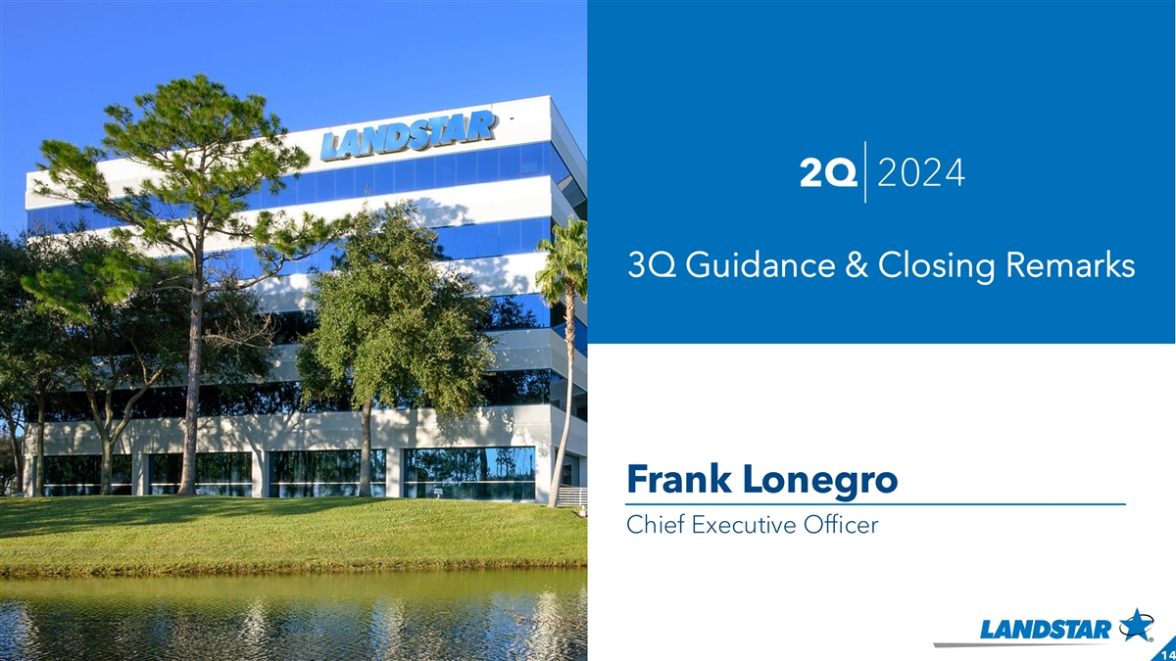
2Q 2024 3Q Guidance & Closing Remarks Frank Lonegro Chief Executive Officer 14

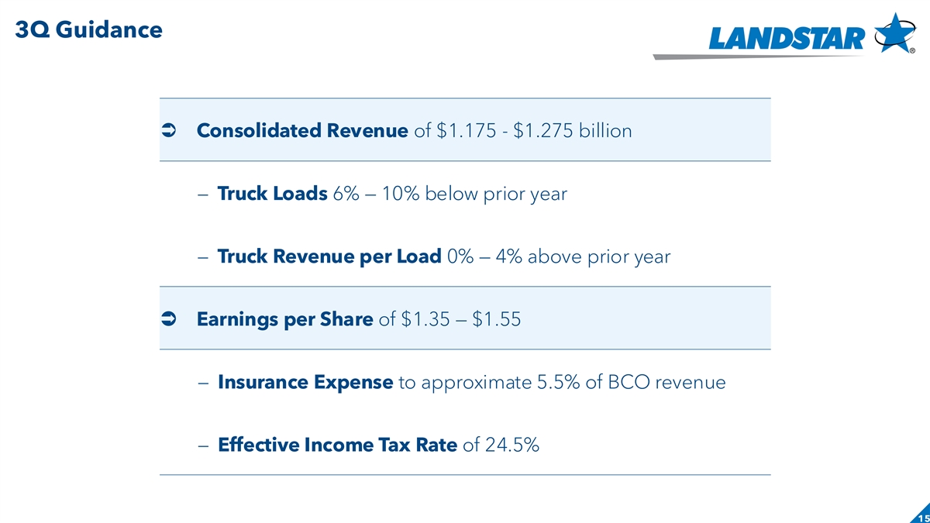
3Q Guidance Slide header Ü Consolidated Revenue of $1.175 - $1.275 billion – Truck Loads 6% — 10% below prior year – Truck Revenue per Load 0% — 4% above prior year Ü Earnings per Share of $1.35 — $1.55 – Insurance Expense to approximate 5.5% of BCO revenue – Effective Income Tax Rate of 24.5% 15

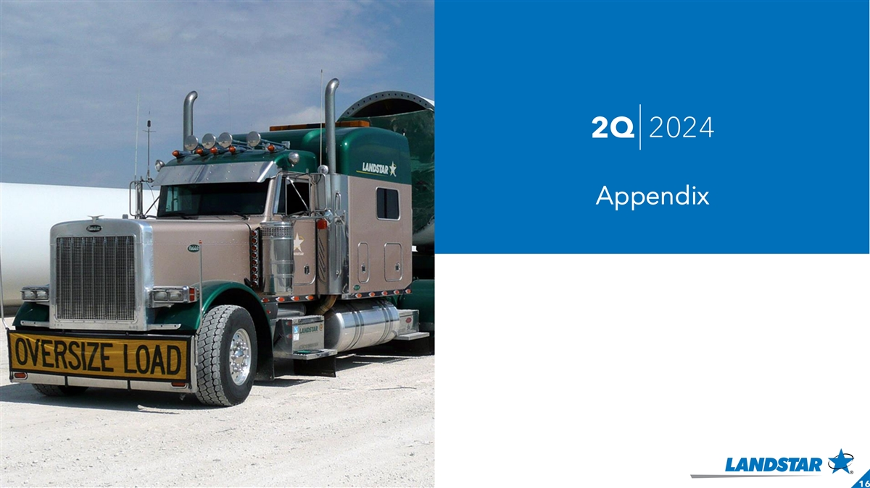
2Q 2024 Appendix 16

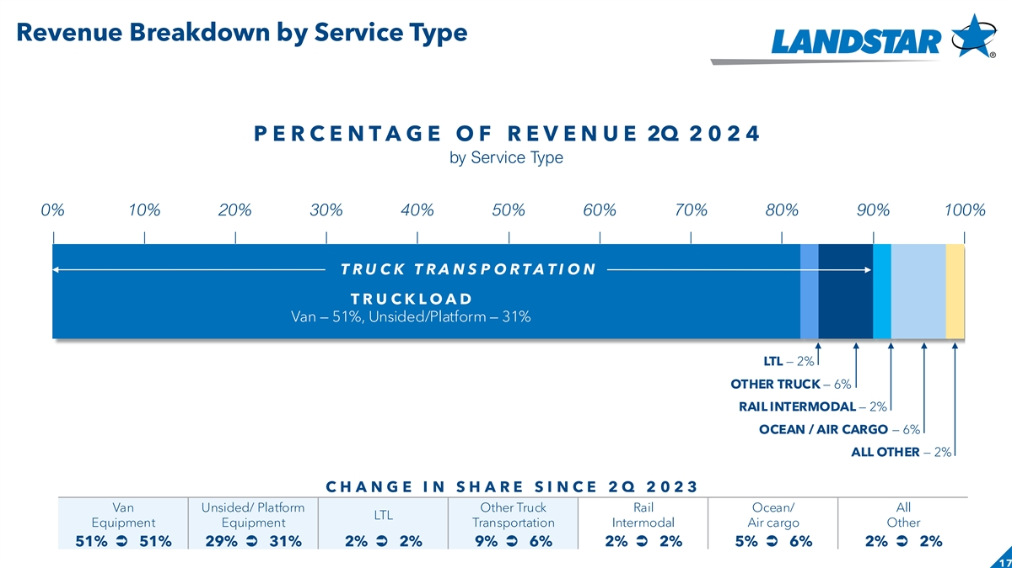
Revenue Breakdown by Service Type P E R C E N T A G E O F R E V E N U E 2Q 2 0 2 4 by Service Type 0% 10% 20% 30% 40% 50% 60% 70% 80% 90% 100% T R U C K T R A N S P O R T A T I O N T R U C K L O A D Van — 51%, Unsided/Platform — 31% LTL — 2% OTHER TRUCK — 6% RAIL INTERMODAL — 2% OCEAN / AIR CARGO — 6% ALL OTHER — 2% C H A N G E I N S H A R E S I N C E 2 Q 2 0 2 3 Van Unsided/ Platform Other Truck Rail Ocean/ All LTL Equipment Equipment Transportation Intermodal Air cargo Other 51% Ü 51% 29% Ü 31% 2% Ü 2% 9% Ü 6% 2% Ü 2% 5% Ü 6% 2% Ü 2% 17

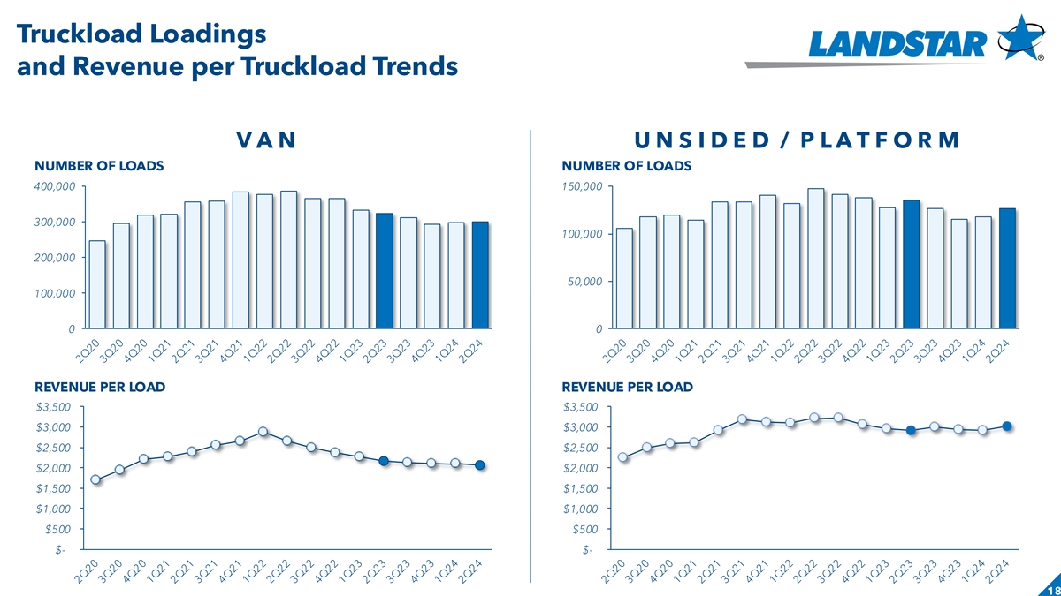
Truckload Loadings and Revenue per Truckload Trends V A N U N S I D E D / P L A T F O R M NUMBER OF LOADS NUMBER OF LOADS 400,000 150,000 300,000 100,000 200,000 50,000 100,000 0 0 REVENUE PER LOAD REVENUE PER LOAD $3,500 $3,500 $3,000 $3,000 $2,500 $2,500 $2,000 $2,000 $1,500 $1,500 $1,000 $1,000 $500 $500 $- $- 18

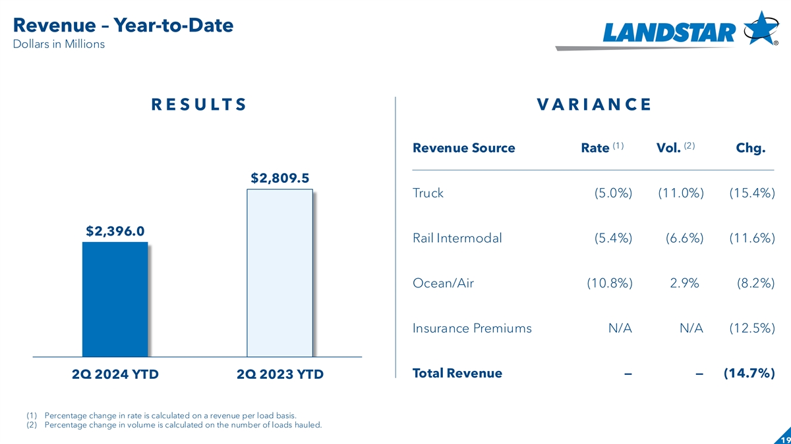
Revenue – Year-to-Date Slide header Dollars in Millions R E S U L T S V A R I A N C E (1) (2) Revenue Source Rate Vol. Chg. $2,809.5 Truck (5.0%) (11.0%) (15.4%) $2,396.0 Rail Intermodal (5.4%) (6.6%) (11.6%) Ocean/Air (10.8%) 2.9%) (8.2%) Insurance Premiums N/A N/A (12.5%) Total Revenue—— (14.7%) 2Q 2024 YTD 2Q 2023 YTD (1) Percentage change in rate is calculated on a revenue per load basis. (2) Percentage change in volume is calculated on the number of loads hauled. 19

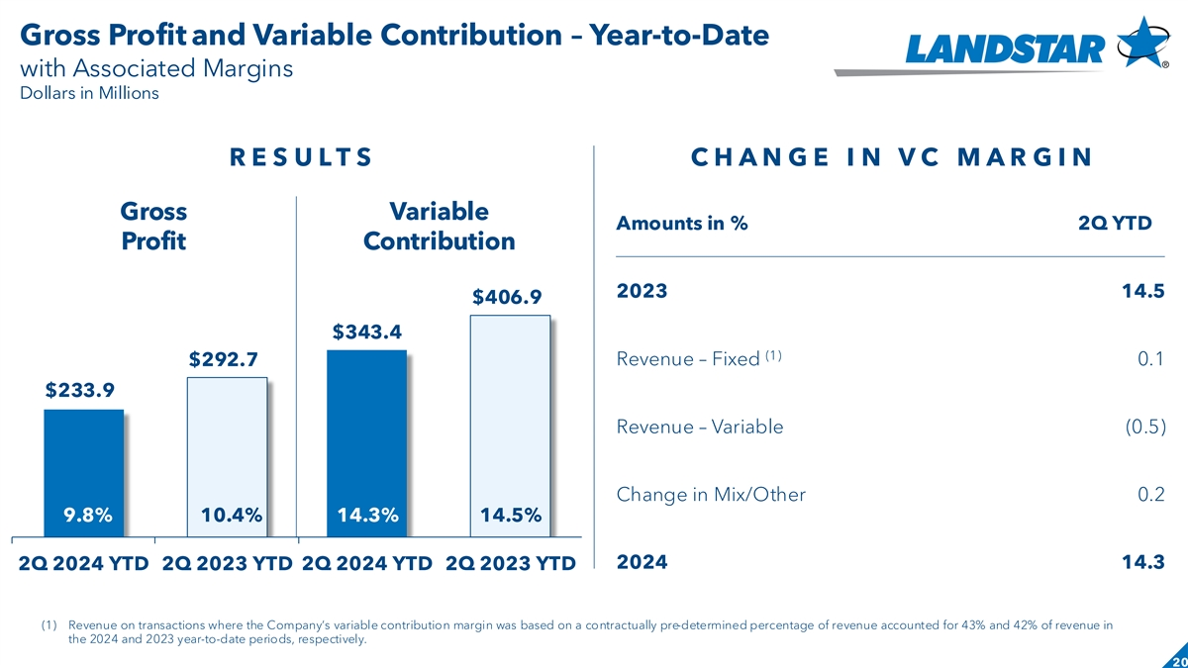
Gross Profit and Variable Contribution – Year-to-Date with Associated Margins Dollars in Millions R E S U L T S C H A N G E I N V C M A R G I N Gross Variable Amounts in % 2Q YTD Profit Contribution 2023 14.5 $406.9 $343.4 (1) $292.7 Revenue – Fixed 0.1 $233.9 Revenue – Variable (0.5) Change in Mix/Other 0.2 9.8% 10.4% 14.3% 14.5% 2024 14.3 2Q 2024 YTD 2Q 2023 YTD 2Q 2024 YTD 2Q 2023 YTD (1) Revenue on transactions where the Company’s variable contribution margin was based on a contractually pre-determined percentage of revenue accounted for 43% and 42% of revenue in the 2024 and 2023 year-to-date periods, respectively. 20

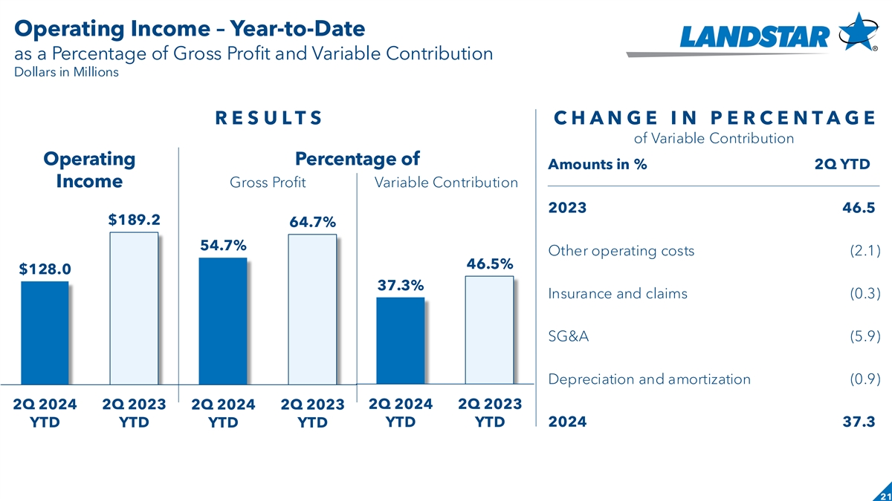
Operating Income – Year-to-Date Slide header as a Percentage of Gross Profit and Variable Contribution Dollars in Millions R E S U L T S C H A N G E I N P E R C E N T A G E of Variable Contribution Operating Percentage of Amounts in % 2Q YTD Income Gross Profit Variable Contribution 2023 46.5) $189.2 64.7% 54.7% Other operating costs (2.1) 46.5% $128.0 37.3% Insurance and claims (0.3) SG&A (5.9) Depreciation and amortization (0.9) 2Q 2024 2Q 2023 2Q 2024 2Q 2023 2Q 2024 2Q 2023 YTD YTD 2024 37.3) YTD YTD YTD YTD 21

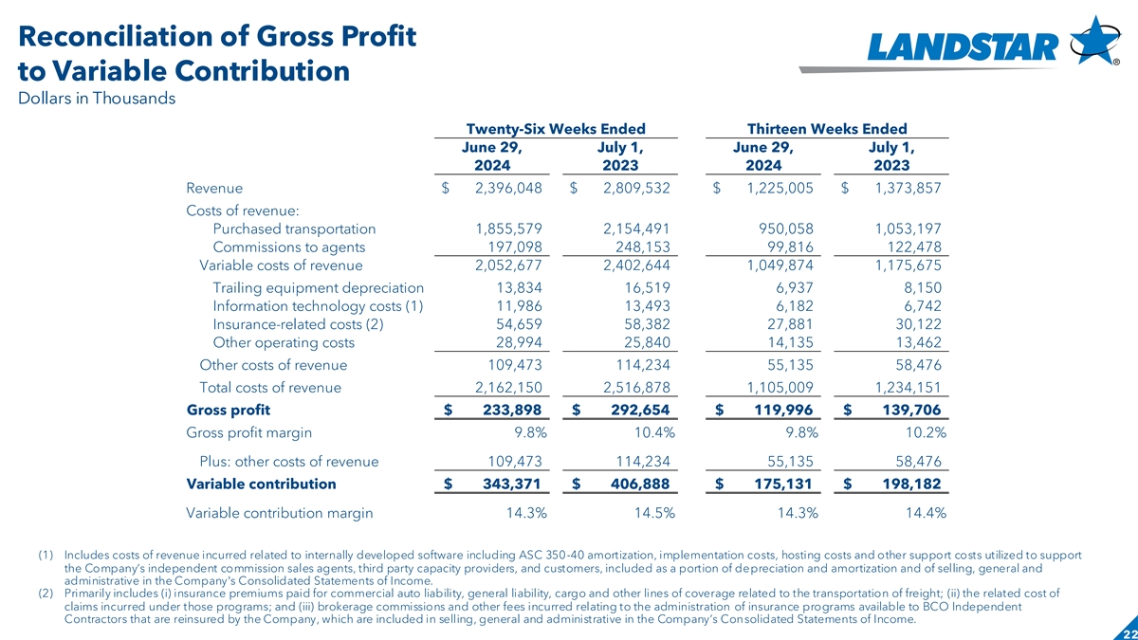
Reconciliation of Gross Profit to Variable Contribution Dollars in Thousands Twenty-Six Weeks Ended Thirteen Weeks Ended June 29, July 1, June 29, July 1, 2024 2023 2024 2023 Revenue $ 2,396,048 $ 2,809,532 $ 1,225,005 $ 1,373,857 Costs of revenue: Purchased transportation 1,855,579 2,154,491 950,058 1,053,197 Commissions to agents 197,098 248,153 99,816 122,478 Variable costs of revenue 2,052,677 2 ,402,644 1 ,049,874 1,175,675 Trailing equipment depreciation 13,834 16,519 6,937 8,150 Information technology costs (1) 11,986 13,493 6,182 6,742 Insurance-related costs (2) 54,659 58,382 27,881 30,122 Other operating costs 28,994 25,840 14,135 13,462 Other costs of revenue 109,473 114,234 55,135 58,476 Total costs of revenue 2,162,150 2,516,878 1,105,009 1,234,151 Gross profit $ 2 33,898 $ 2 92,654 $ 1 19,996 $ 1 39,706 Gross profit margin 9.8% 10.4% 9.8% 10.2% Plus: other costs of revenue 109,473 114,234 55,135 58,476 Variable contribution $ 343,371 $ 406,888 $ 1 75,131 $ 198,182 Variable contribution margin 14.3% 14.5% 14.3% 14.4% (1) Includes costs of revenue incurred related to internally developed software including ASC 350-40 amortization, implementation costs, hosting costs and other support costs utilized to support the Company’s independent commission sales agents, third party capacity providers, and customers, included as a portion of depreciation and amortization and of selling, general and administrative in the Company's Consolidated Statements of Income. (2) Primarily includes (i) insurance premiums paid for commercial auto liability, general liability, cargo and other lines of coverage related to the transportation of freight; (ii) the related cost of claims incurred under those programs; and (iii) brokerage commissions and other fees incurred relating to the administration of insurance programs available to BCO Independent Contractors that are reinsured by the Company, which are included in selling, general and administrative in the Company’s Consolidated Statements of Income. 22

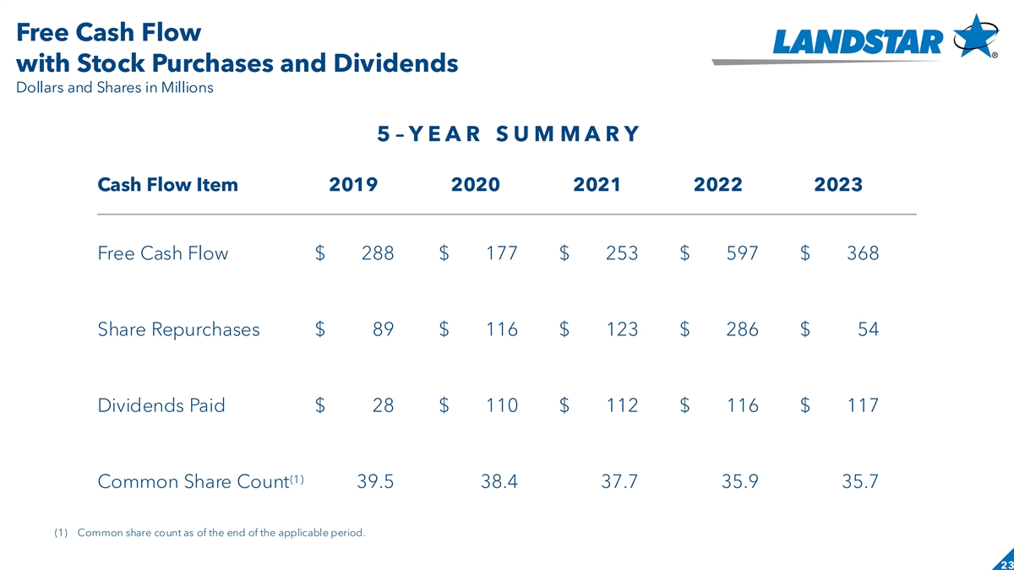
Free Cash Flow with Stock Purchases and Dividends Dollars and Shares in Millions 5 – Y E A R S U M M A R Y Cash Flow Item 2019 2020 2021 2022 2023 Free Cash Flow $ 288 $ 177 $ 253 $ 597 $ 368 Share Repurchases $ 89 $ 116 $ 123 $ 286 $ 54 Dividends Paid $ 28 $ 110 $ 112 $ 116 $ 117 (1) Common Share Count 39.5 38.4 37.7 35.9 35.7 (1) Common share count as of the end of the applicable period. 23

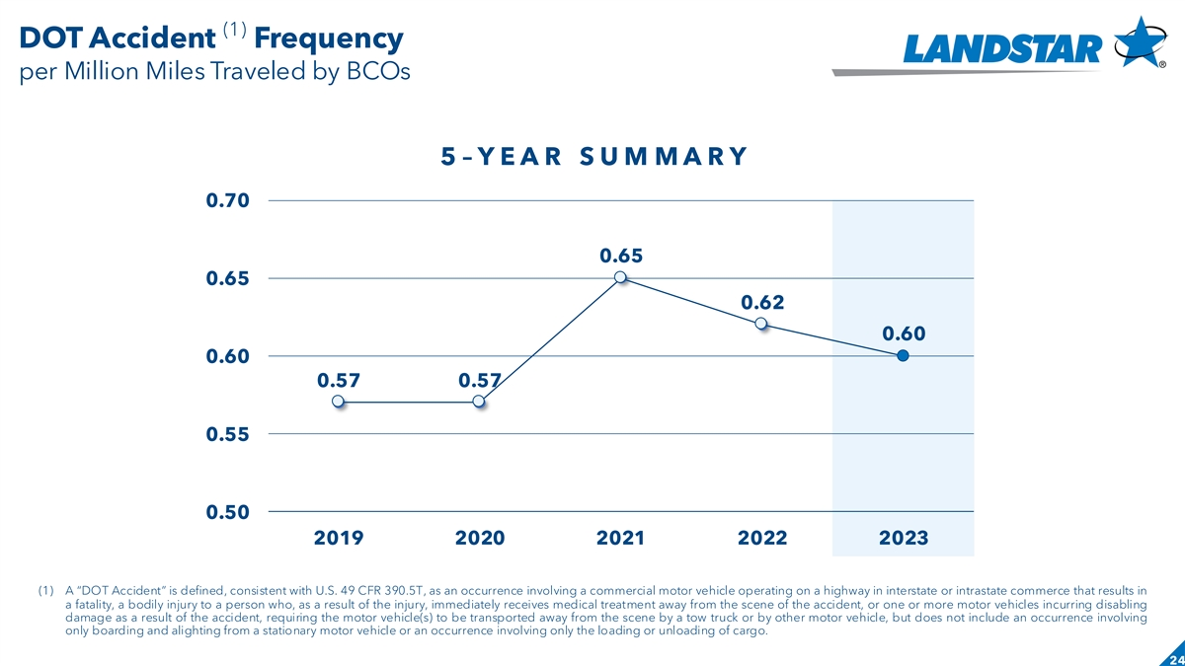
(1) DOT Accident Frequency per Million Miles Traveled by BCOs 5 – Y E A R S U M M A R Y 0.70 0.65 0.65 0.62 0.60 0.60 0.57 0.57 0.55 0.50 2019 2020 2021 2022 2023 (1) A “DOT Accident” is defined, consistent with U.S. 49 CFR 390.5T, as an occurrence involving a commercial motor vehicle operating on a highway in interstate or intrastate commerce that results in a fatality, a bodily injury to a person who, as a result of the injury, immediately receives medical treatment away from the scene of the accident, or one or more motor vehicles incurring disabling damage as a result of the accident, requiring the motor vehicle(s) to be transported away from the scene by a tow truck or by other motor vehicle, but does not include an occurrence involving only boarding and alighting from a stationary motor vehicle or an occurrence involving only the loading or unloading of cargo. 24

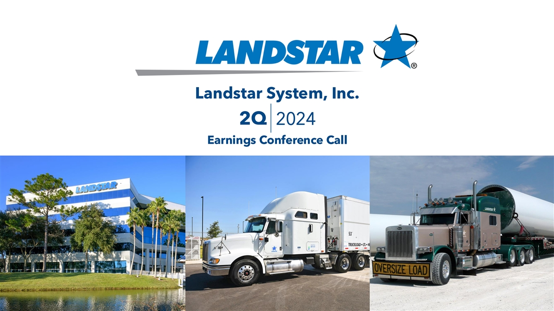
Landstar System, Inc. 2Q 2024 Earnings Conference Call Date

